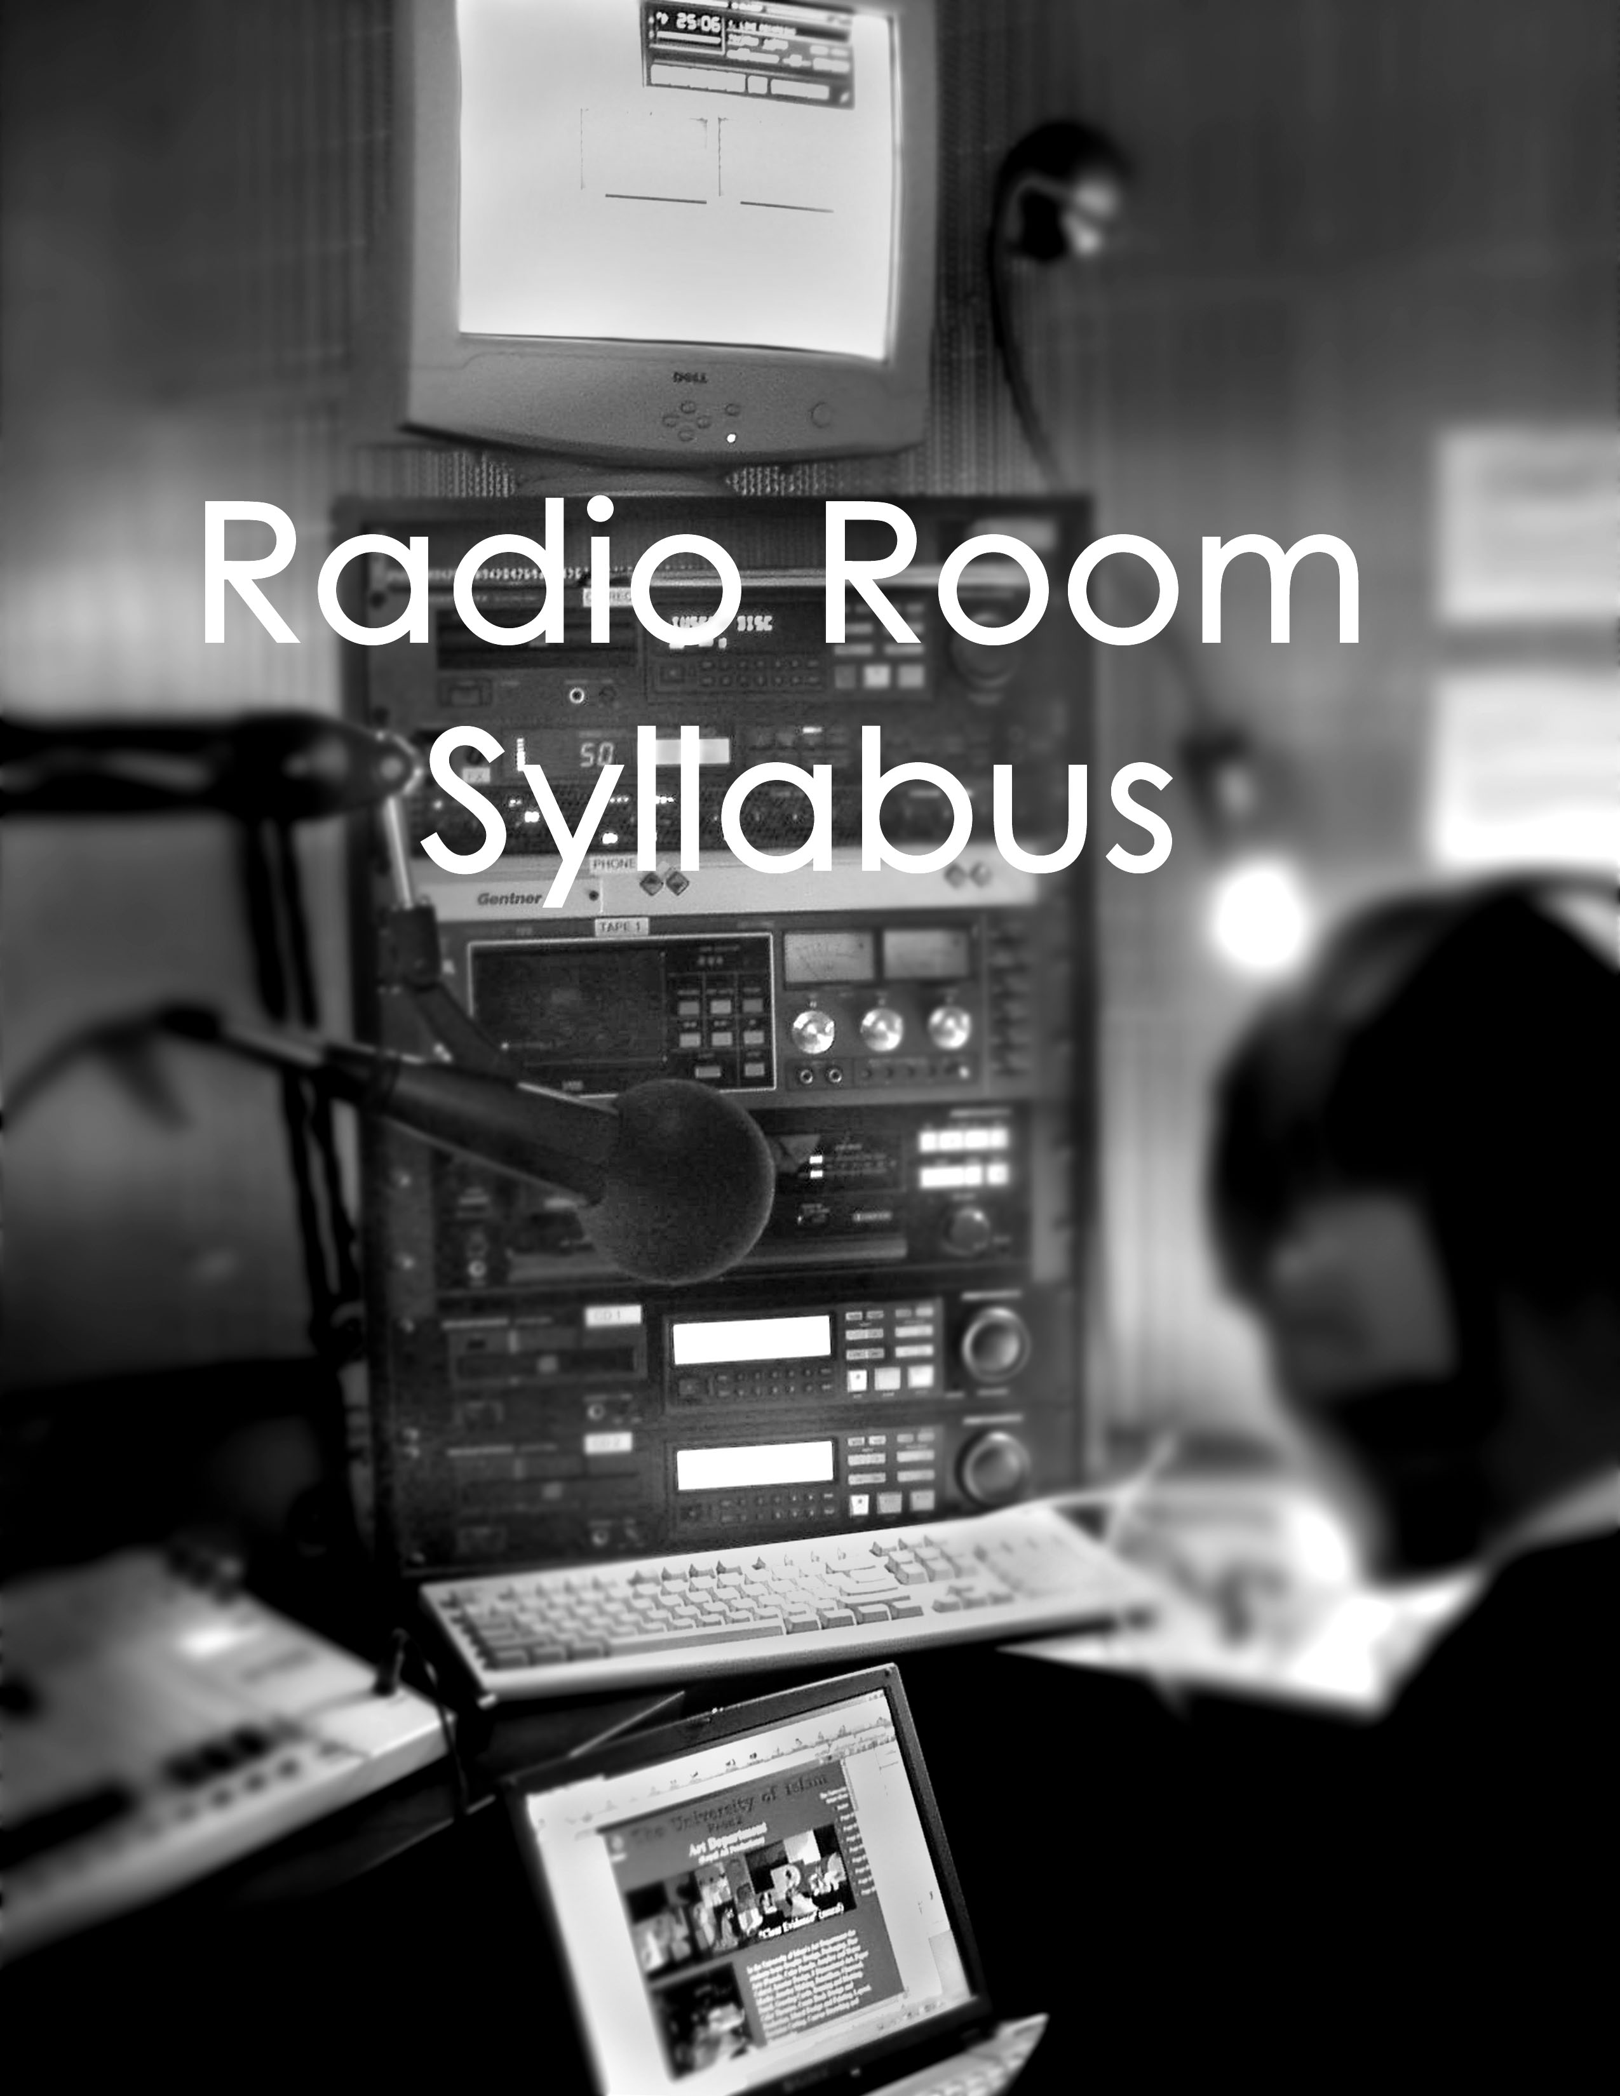

Internet Radio
Saturdays– 3:00-5:00 p.m., 1st Floor Media Bridges

Instructor: Katie Finnigan Office Phone: (513) 651-4171
E-mail: katie@mediabridges.org
Office Hours: by appointment
Required Text:
Your AWESOME Volunteer Handbook

Recommended Text:
Kaempfer, R., & Swanson, J. (2004). The radio producer's handbook. Allworth Press.

Geller, V. (2007). Creating Powerful Radio: Getting, Keeping and Growing Audiences News, Talk, Information & Personality Broadcast, HD, Satellite & Internet Focal Press

Objectives/Learning Outcomes for this Course:
The goal of this course is for you to learn the technical and theoretical aspects of radio production. This will be achieved through in-class instruction and discussion, mandatory practice time, and in-class activities. This course should help you:

- Develop a working knowledge of the WVQC and its components
- Understand the process for connecting to the Media Bridges stream
- Properly communicate with your crew and guests
- Understand the pre-production process as it applies to live radio
- Understand the process and responsibilities of airing radio content at WVQC/ Media Bridges

Explanation of Course Expectations:
These are the expectations for ALL of those enrolled in the class.
- Certification: Your course certification involves a manual test demonstrating knowledge of airing a show in the Internet Radio Room. Details of the test can be found in the course handout. Certification occurs on the last day of class. NO EXCEPTIONS. If you fail to certify, you will need to repeat the course.

- Class Participation: When in class, it is expected that everyone participates and is there to focus on the course material. While there will be PLENTY of time for everyone to share with each other and chat, when the instructor is speaking, please don’t make it hard for others to hear by talking over them. All cell phones must be set to vibrate.

- Attendance: It is required that you attend all classes to receive certification in the course.

Radio Room Syllabus

Day 1
- Meet and Greet
- Media Bridges Tour and Overview
- Radio Room Policy
- Equipment Overview and connecting to the Internet

Day 2
- FCC Regulations
- Log Keeping
- Cont. / Review Equipment Demonstration
- Practice

Day 3
- Go over telephone calls
- Any questions and last chance for quick practice session
- Certification

Certification
Prepare a 10 – 15 minute show
- Record show
- Read radio room disclaimer
- Play at least 2 songs
- Demonstrate ability to cue a song while one is streaming
- Air 1 station ID and 1 underwriting announcement
- Talk
- Talk over music
- Monitor levels accurately
- Fill out a log
Pass a written quiz on WVQC policy and FCC regulations
Sit in on a producer’s show

For certification, producers are welcome to bring guests, have phone in callers and bring in their own music in the form of cds, mp3 players, cassette tapes, and records.
About Media Bridges

Media Bridges is Cincinnati’s community media center. It was founded in 1989 as the public and educational cable access center for the city of Cincinnati. Since its beginnings, Media Bridges has grown to a full-scale media arts education facility, continuing to steward the city’s four cable access channels provided by Time Warner Cable. Media Bridges’ continues to foster a local voice for the residents of Cincinnati.

In March of 2002, Media Bridges moved to its current facility in Over-the-Rhine. While serving as a cultural “bridge” in Cincinnati, Media Bridges offers the following services at no cost to its constituents:

- Distribution of media produced by local individuals via four community television channels, accessed by over 166,000 households in Hamilton County
- Multi-use facility and state-of-the-art video production equipment for community use
- Beginning and advanced technology classes in video, audio and computer skills
- Youth programs that engage local schools and community organizations in the construction and evaluation of media

Mission
Media Bridges provides the education, equipment and environment to assist people in communicating effectively through media.

Media Bridges offers solutions to the community’s communication needs by offering a means for citizens to let their opinions be heard – by voicing concerns using various tools of media such as television, radio and the internet. Media Bridges provides free media production classes to any individual or group. We set out to create a welcoming space for the public to come together to find solutions and share them. Not only does Media Bridges offer free classes, but we also offer the means to create media productions. Media Bridges loans out equipment for free, library style, including cameras, microphones, computers and studios, so that people can create messages to take to the citizens of Cincinnati via Media Bridge’s cable channels, radio station and websites.

About WVQC

WVQC, Radio Free Queen City is a low-power, community radio station broadcasting on 95.7 FM. We’re operated by Media Bridges, Cincinnati’s community media center in historic Over-the-Rhine. WVQC is non-commercial, member-supported radio. Our programs are produced by talented volunteers like you.

Media Bridges applied for a low power FM license in January 2001. We finally received a construction permit in 2008.

Mission
WVQC provides a platform for local, diverse voices within Cincinnati’s communities, especially the urban core. It serves our neighborhoods as a source of information and entertainment relevant to the needs of both residents and businesses.

The flexible programming policy of WVQC encourages the public to participate in community conversation by both live and pre-recorded broadcasting. Its emphasis on local matters extends from governance initiatives, education and media training opportunities; to underrepresented cultures prevalent in Cincinnati; to activist groups and the local arts and music scene.

WVQC’s airwaves will stream with creative, educational and lively content that our communities want and are willing to support. We strive to open up the airwaves to all the voices of the Queen City. At WVQC, we build community through radio.

Time-sharing
WVQC shares it’s time on the air with two other organizations: the Holy Spirit Center and the Forest Hills School District. We are on the air 51 hours a week and we stream on the Internet 24/7.

What is low-power radio?
Low-power FM, or LPFM stations are small, up to 100-watt radio stations with a signal reach of just a few miles. They are non-commercial, locally-owned, innovative ways for local communities to take back their airwaves.

The LPFM license was legalized by the Federal Communications Commission (FCC) in 2001 to combat consolidation and the decline of independent, community-accountable radio stations on the FM dial.

The signal reach of 3-5 miles or less allows LPFMs to be anchored and accountable to the community and to develop closer, more personal relationships with the neighborhoods we serve. The smaller station also comes with a smaller budget that is more sustainable for community and non-profit groups.

LPFM stations provide an alternative to corporate, cookie-cutter programming on commercial radio. They're designed to bring creativity, vitality and localism back to the FM dial.

LPFM stations are:
- Non-commercial
- Licensed to non-profits or municipalities
- Locally owned
- Independent
- Broadcasters of locally produced programming
- 100 watts or less

Station structure
WVQC is a division of Media Bridges, Cincinnati’s non-profit community media center. Media Bridges hold the license and Media Bridges’ Board of Trustees, along with the Executive Director have the final say in all station operations. Other staff and volunteers working on WVQC include:

Advisory Board: The Advisory Board was created by the Board of Trustees to craft the policies and procedures of WVQC. The Advisory Board consists of 1 member of the Board of Trustees, 4 members appointed by the Board of Trustees and 2 members elected by members of WVQC.

LPFM Facilitator: Katie Finnigan is the LPFM Facilitator, a position funded by a grant through the AmeriCorps VISTA program. If you have general questions about the station, please see her.

Development Coordinator: Christa Zeilke, Media Bridges’ Development Coordinator, handles the fundraising for WVQC. If you have questions about underwriting, donations or fundraising, see her.

Policies, Rules and Procedures

Membership
Membership provides WVQC with much-needed operating funds as well as an opportunity for individuals to create their own content and programming for potential airing on the station.

WVQC members can apply to host shows, vote in Advisory Board elections and get discounts on special events.

There are three membership levels* to fit any budget – “DJ,” “MC,” and “Mixmaster”.

- DJ: $30, Includes a WVQC sticker as our gift to you.
- MC: $75, Includes a WVQC t-shirt as our gift to you.
- Mixmaster: $150, Includes a WVQC t-shirt and 2 free tickets to a WVQC event as our gift to you.

*In special cases, membership dues may be waived for individuals experiencing financial hardship – however this will be determined on a case-by-case basis by Media Bridges staff.

Hosting a Show
WVQC is a volunteer-powered radio station and our shows are produced and hosted by community volunteers like you.

How to get a show on WVQC:
It’s as easy as 1, 2, 3.

Step 1: Become a member. You can do this at the Media Bridges front desk or on www.wvqc.org/member

Step 2: Complete a WVQC training course. Make sure you read this handbook too. You can find a course schedule at www.wvqc.org/member.

Step 3: Submit an application and it will be considered at the Advisory Board’s next meeting. Producers have the option to submit a 10-15 minute sample of their show to the Board. The Board may also request a 10-15 minute sample.

All WVQC Producers must:
- Be a member in good standing on WVQC
- Be certified in the Low Power FM training class
- Participate in WVQC fund drives
- Adhere to all station rules and policies
- Be present and on time for programming slots or find a qualified substitute

Program Selection and Review

Program selection criteria: To apply for a program, submit an application along with a 15 minute sample of your show to the Radio Advisory Board. WVQC is looking for programs that:

- Are informative for our neighborhoods, by promoting civic engagement and community outreach
- Reach diverse groups underserved by mainstream media
- Play local music and other local content

Annual Review: To keep fresh, high quality programs on the air, each show will be reviewed once a year by the Advisory Board. They will consider: audience size, loyalty and feedback; underwriting revenue brought in by the program; producer seniority; and adherence to rules and policy. The results of the review will determine whether a program is eligible for renewal.

Guests and Substitution Policy

Substitution Policy: When a producer cannot host their scheduled show, they are responsible for finding a qualified substitute or submitting a recording of their show to play during their time slot. All shows should leave a back-up recording of their show at WVQC to play in case of emergencies. If can’t make your show notify Katie 24 hours in advance to play the recorded show during your time slot.

All subs should be members of WVQC and have been certified to host shows. You can find subs by posting flyers on the Media Bridges bulletin board or by emailing or calling producers directly. If an emergency arises and you have tried every avenue but are not able to find a substitute, call the WVQC Facilitator.

No Show Policy: For WVQC to build a reliable audience, our listeners need to know that their favorite show will be on when they tune in. After one missed show without a back-up recording or a substitute host, the producer will be given a written warning. After two missed shows, the show will be cancelled.

Guests: WVQC producers are welcome and encouraged to invite guests onto their shows. However, guests that appear on a show more than 50% of the time will be considered co-hosts and will be required to become members of the station and complete training.

On-air Announcements

Disclaimer:
Please announce the following disclaimer at the start of your show.

WVQC, as a community radio station, serves only to open its airwaves to responsible, divergent points of view. The opinions expressed on this program do not reflect the views of WVQC, Media Bridges’, its staff or its board of trustees. The opinions expressed reflect the views of the programmer or their guests. Thanks for listening.

Station Identification: At the top of every hour, as close to the hour as possible, all producers must announce: “You’re listening to WVQC-LP Cincinnati, 95.7FM.”

Station ids are required by the FCC at the top of the hour, but it doesn’t hurt to do them throughout your show, too. After you’ve made that announcement, you might want to add more information such as:

- Radio Free Queen City | - Member-supported radio
- Non-commercial, community radio | - Your local alternative
- Independent radio | - Volunteer-powered radio

Recorded ids are available in the Station ID folder on iTunes, and producers are welcome to play a recorded id instead of making a live announcement.

Donations and Sponsorship

Underwriting:
WVQC is a non-commercial station and does not air advertising. Instead, we air underwriting announcements, recognizing sponsors who donate to the station.

Finding sponsors:
Underwriting sponsorship is vital to helping WVQC pay its bills and stay on the air. If you can find an underwriter who will sponsor your show for $200 or more, we will waive your membership fee. All underwriting sponsorship must go through WVQC. If you have an underwriter, let the Development Coordinator know.

Broadcasting announcements:
Underwriting announcements are not advertisements. The language we may use is restricted and may not include information on prices or calls to action (buy now, stop by today etc.). Underwriting announcements cannot interrupt programs, instead they must be aired at the beginning or end of a show.

At the beginning and end of your show, check the Operator Log to see if you are scheduled to broadcast an underwriting announcement. If you are asked to read an announcement, please do so word for word. If you are asked to play a pre-recorded spot, please do so at the specified time.

Donations:
WVQC is a non-profit station and donations are vital to helping us stay on the air. If you have a connection with a possible donor, please let the Development Coordinator know.

In-kind donations of merchandise, tickets or music are also welcome at WVQC and may be used to add to our music library, as thank-you gifts for fundraising drives, or to give away as contest prizes.

All donations of tickets, music, money or merchandise are considered donations to WVQC and must be reported to the Development Coordinator.

If you receive an in-kind donation that you would like to give away as a contest prize on your program, consult the Development Coordinator. Remember to talk to the LPFM Facilitator for a complete list of contest rules.

Membership drives: Several times a year WVQC holds on-air membership drives to raise money for the station. Producers take part by airing announcements on their show. Volunteer opportunities will also be available during the drive.

Log Keeping

Program Log: The program log is located in a binder in the radio room. It must be filled out by every producer during their show.

- At the beginning of their show, producers should open the log to the correct date/ time slot and sign in.
- During their show, producers must record when underwriting and station ids are played. It is important that announcements are played as close to the scheduled time as possible.
- The program log will tell producers which underwriting announcements should be played during their show and where they are located. ‘Live’ means a producer should turn to the underwriting section in the back of the binder and read the correct announcement word-for-word. ‘PC’ means a producer should play the correct announcement from the underwriting playlist in iTunes.
- After the show, the producer should jot down the topics covered in the show and make a note of any issues or problems.

Denial of Access Privileges:

- Media Bridges may request that a person leave Media Bridges premises for reasons including but not limited to the following:
  - If they are under the influence of alcohol or drugs or if they sell or otherwise dispense alcohol and/or drugs.
  - If they interfere with the orderly conduct of Media Bridges activities of programs.

- The following are MAJOR OFFENSES against Media Bridges Rules and Procedures. Such offenses result in immediate, permanent loss of access privileges and/or suspension of such privileges and probationary sanctions of 90 days:
  - Misuse of abuse of Media Bridges equipment or facilities.
  - Theft or vandalism of the property of Media Bridges, of Warner Cable, or of any Media Bridges staff member, producer, producer in training or visitor.
  - Failure to return equipment through intent, negligence, loss or theft.
  - Making false or misleading statements on any Media Bridges document.
  - Use of equipment or facilities for commercial or profit-making purposes.
  - Use of Media Bridges equipment or facilities for any purpose other than cablecast.
  - Removal of equipment from a Media Bridges facility without proper sign out and supervision by a Media Bridges staff member.
  - Use of equipment by non-certified or probationary users.
  - Chronic and willful disregard for Media Bridges Rules and Procedures.
  - Abuse or harassment of Media Bridges staff.
  - Violation of FCC Regulations

- The following MINOR OFFENSES against Media Bridges Rules and Procedures may result in probationary sanctions:
  - Failure to return equipment on time or to cancel a reservation with sufficient notice.
  - Late return of equipment without an authorized extension.
  - Return of functional but dirty equipment.
  - Unsafe or improper use of equipment.
  - Improper packaging of equipment for transport.
  - Attempted disassembly or repair of any Media Bridges equipment.
  - Reservation on behalf of others.
  - Smoking, drinking or eating in any restricted area or equipment areas of Media Bridges.

- Disciplinary Action:
  - For a first offense, in the case of a Minor Offense, the producer committing the offense will be given a verbal warning by the Media Bridges staff member.
  - For the second offense, in the case of a Minor Offense, the producer will receive a written warning. One copy of this warning will be placed in the producer's file, and another copy will be given to the Executive Director.
  - For the third offense, in the case of a Minor Offense, the producer will be placed on probation. During the probationary period all access privileges with Media Bridges are suspended.
  - Immediate suspension of privileges may be imposed for a Major Offense.

- Probationary Sanctions:
  - The first sanction will be a 90-day suspension.
  - The second sanction will be a 1-year suspension.
  - The third sanction will result in permanent expulsion of access privileges with Media Bridges.
  - Other sanctions to be prescribed by the Executive Director include, but are not limited to:
    - Requirement of re-attending orientations sessions.
    - Requirement of demonstrated proficiencies of understanding.
    - Short-term probationary periods.

Grievance Policy:

Appealing programming decisions:
- WVQC producers may appeal programming decisions in the following manner:
  - Submit a written statement to the Advisory Board and request a written explanation for the programming decision with constructive feedback for the producer.
  - Make adjustments to their application and reapply for an open programming slot.
- WVQC producers may make a final appeal in the following manner:
  - File a written appeal with the Media Bridges Board of Trustees.
  - Decisions of the Board of Trustees are final.

Appealing sanctions:
- WVQC producers may appeal sanctions in the following manner:
  - File an appeal with the Radio Advisory Board of the Media Bridges Board of Trustees within 10 days of the imposed sanction.
  - Appear before the Radio Advisory Board for the purpose of making a presentation on the circumstances of the sanctions and the appeal.
- WVQC producers may make a final appeal in the following manner:
  - File an appeal with the Media Bridges Board of Trustees within 10 days of the Radio Advisory Board’s decision.
  - Appear before the Board of Trustees for the purpose of making a presentation on the circumstances of the sanctions and the appeal.
  - Decisions of the Board of Trustees are final.

Other Important Policies

Food and drink in the station: No food is permitted in the radio room. No drinks without a covered lid are permitted in the radio room.

Right to pre-empt: WVQC reserves the right to pre-empt scheduled programming for special events or emergencies. If possible, at least one week prior warning will be given to producers whose shows will be affected. A make-up time slot may be scheduled if one is available.

Commercialization: Producers cannot utilize programs produced with Media Bridges equipment for any commercial use.

FCC Rules and Regulations for On-Air Conduct

The Federal Communications Commission (FCC) is an independent federal agency that is responsible for regulating interstate and international communications, including radio and television.

The FCC issues broadcast licenses for radio stations and sets regulations that attempt to ensure that the station operates in the public interest.

Because they have the power to give and take away licenses, FCC restrictions for FM radio stations such as WVQC are much stricter than they are for cable TV or Internet radio. Therefore, content that is ok to broadcast on Media Bridges’ public access channels or Internet radio station is not necessarily ok to broadcast on WVQC.

WVQC takes FCC rules very seriously. While creative, thought-provoking programming is encouraged, broadcasters must remember that WVQC operates on a small budget, and is in no position to take on the FCC. A single large fine could shut us down. WVQC producers are required to sign Statement of Compliance and agree to be held liable for any fines they incur.

Any violation of the FCC regulations listed below can result in the producer’s suspension or loss of on-air privileges. If you have doubts over whether the content you plan to air violates FCC rules, consult the LPFM Facilitator before you air it.

Restricted Speech

Obscenity:
Obscenity is not protected by the First Amendment and may never be aired on WVQC.

What makes a broadcast obscene? The Supreme Court has determined that three elements must be present:

- An average person, applying contemporary community standards, would find the material, taken as a whole, appeals to the prurient interest.*
- The material depicts or describes, in a patently offensive way, sexual conduct specifically defined by applicable law.
- The material, taken as a whole, lacks serious literary, artistic, political or scientific value.

*“Contemporary community standards” applies to the community as a whole, not just the people who may be listening to your broadcast.

Indecency:
Indecency is protected by the First Amendment, but regulated by the FCC. It may only be aired on the radio between 10:00 p.m. and 6:00 a.m., the ‘safe harbor hours,’ when children are not likely to be in the audience.

The standard for indecency is stricter that the standard for obscenity. It is defined by the FCC as, “language or material that, in context, depicts or describes, in terms patently offensive, as measured by contemporary community standards for the broadcast medium, sexual or excretory activities or organs.”

In other words, the FCC doesn’t want you to talk about what happens in the bedroom or the bathroom, as least not before 10 pm.

Indecency is often defined as the “Seven Dirty Words.” However, a broadcast does not have to contain one of the prohibited words to be patently offensive. Strong innuendo may be considered indecent “if it is understandable and clearly capable of a specific sexual or excretory meaning which, in context, is inescapable.”

Unlike obscenity, artistic merit is not taken into account when determining if material is indecent. A classic novel is never obscene, but it may be indecent.
Remember that music can be considered indecent too. A single dirty word in the background is enough to make an entire song indecent. Music with strong innuendo, such as repeated sexual moans and groans, can also be considered indecent.

Profanity:
In the past, profanity has been regulated as its own category of speech. Today, the FCC is increasingly evaluating profanity cases using it’s indecency standard.

However, Broadcasters should refrain from using swear words outside of the ‘safe harbor’ hours of 10 p.m. to 6 a.m., even if they are not included in the “Seven Dirty Words.”

Avoiding Indecency and Profanity:
The Supreme Court has recently ruled that even accidental, “fleeting,” dirty words may be considered indecent. To avoid a slip-up, be sure to listen to songs all the way through before you air them, screen live callers, and inform guests about the policy.

If you do accidently air a song with an indecent word, immediately fade it out. If a caller begins swearing, hang-up the phone. If you or a guest lets a wrong word slip, change the topic. Move on with the broadcast and don’t apologize, mention or otherwise draw attention to any slip-ups on the air.

Broadcasting During Election Season

Political Log: When a producer interviews or endorses a candidate for political office they should fill out a page of the political log, located in the same binder as the program log. They should also fill out the log if they play a clip of a candidate’s voice or if a candidate requests airtime.

Political Endorsements: As a non-commercial station, WVQC does not endorse political candidates or take sides in political races. However, individual producers or their guests may endorse candidates as long as they include the following disclaimer immediately prior to or following the endorsement:

The opinions expressed are my own (or those of my guest). The opinions expressed are not those of WVQC, Media Bridges, its staff or its board of trustees.

Equal Opportunity:
As a steward of the airwaves, WVQC has an obligation to offer equal opportunities to all legally qualified candidates for public office.

WVQC producers are welcome to interview candidates for public office or play clips of candidate speeches on the air. However, whenever a candidates ‘ voice is heard on the air the producer must make a note of it in the Political File. Bear in mind that you may also be required to give the candidates’ opponent equal airtime on your show.

This rule can also apply to supporters of a candidate for public office. Anytime you or a guest on your program endorses a candidate for public office, record the endorsement in the Political File.

Requests for Airtime:
If a candidate for public office requests airtime, it must be logged in the Political File. A producer is only required to honor requests if they qualify for equal opportunity airtime. If you receive a request for airtime by a political candidate, consult the LPFM Facilitator to determine if the candidate meets the equal opportunity rules.

Political Candidates: A producer must resign their on-air position if they are running for public office.

Political and Public Issue Ads:
WVQC is prohibited from airing advertisements for political issues or political candidates in exchange for compensation.

A producer may air an advertisement that promotes a political candidate or deals with a political issue for the purpose of analyzing or commenting on it, as long as they receive no compensation for airing it. Before the ad airs, they should identify the person or organization responsible for the spot.

If the ad includes clips of a candidates’ voice it may be subject to equal airtime rules and the producer must make a record of it in the Political File.

Other Restrictions

Taped and Recorded Material: If a producer pre-records their show for later broadcast, they must disclose at the beginning of the program that it has been pre-recorded.

Copyright Laws:
WVQC has purchased broadcasting rights for commercially recorded music. A producer may air any material that has been commercially recorded (as long as it meets FCC rules). However, it is illegal to broadcast “bootleg” recordings or other non-commercial recordings without the written permission of the artist.

If you want to read written material on the air, you must adhere to the “fair use rule.” The “fair use rule demands that the material you read or quote on the air should not take away any of the financial value of the printed work. If you read the entire work, that can be construed as violating the ‘fair use rule.’ How much of the work you can read without violating the ‘fair use rule’ is a matter of interpretation. When in doubt, get written permission.”

Note: If a printed work was published before 1923, it is in the public domain and is not subject to copyright restrictions.

Hoaxes: It is illegal to broadcast false information about a crime or catastrophe if the information causes substantial public harm. If you want to air a program about a fictional crime or catastrophe, include a disclaimer at the beginning stating that the program is a work of fiction.

Broadcasting Telephone Calls:
The FCC requires that telephone callers be notified that they’re call is being recorded or that it is on the air before any part of the call is broadcast. Picking up the phone and answering, “Hello, you’re on the air,” is a violation of FCC rules.

Producers that plan to broadcast live telephone calls must pick up the phone while off the air and inform the caller that they plan to put the call on the air. A producer can have a co-host screen calls, or do so themselves during a music break. WVQC requires that all calls must be screened before they go on the air.

Payola and Plugola:
Payola and plugola are both prohibited by the FCC.

Payola is defined “as the broadcast of material for which a station, its employees, producers or program suppliers have received or are promised consideration, without disclosing that the consideration was paid or promised. “

Plugola refers to the “on-air promotion of goods or services in which a person with programming responsibility has a financial interest.”

A producer may not:
- Advertise or promote products, services or events in which he/ she has a financial interest without disclosing that financial interest.
- Advertise or promote products, services or events by organizations who are donors or underwriters to WVQC without disclosing that the organization is a sponsor of WVQC.
- Accept cash or gifts in exchange for influence over programming.
- Solicit on-air donations for any organization, profit or non-profit other than WVQC.

Contests and Lotteries:

Lotteries: Federal law prohibits the broadcast of any, “advertisement of or any lottery or any information concerning a lottery.” Remember that this does not just apply to state lotteries. A lottery must include all of the following elements:

- Prize: Money or anything of value is awarded to the winner.
- Chance: The winner of the prize is determined by chance, rather than skill.
- Consideration: The drawing is exclusive. Participants are required to pay money or contribute something of value, (which can include the expenditure of substantial time or energy), in order to participate.

Contests: Producers may hold contests on their show, but there are several legal restrictions. Consult the LPFM Facilitator before holding any contest to get a complete list of the rules.

Defamation:
Defamation is not regulated by the FCC, but it is illegal under federal law. Defamation is the broadcast or publication of, “a false, factual statement that injures someone’s reputation. Corporations are considered ‘organizational persons’ and, as with individuals, can bring a defamation claim.”

Defamation applies to factual statements, not opinions and the law is much stricter for private than public figures. Claims by public figures may only be brought if false statements were published or broadcast with, “actual malice,” defined as, “actual knowledge of it’s falsity or with ‘reckless disregard for the truth.”

The Radio Room

The Media Bridges website is www.mediabridges.org. To listen to the Bridge click Radio > Listen to the Bridge.

Starting August 1, The Bridge will become WVQC. To listen go to www.wvqc.org/listen.

Radio room and equipment

We use the format of MP3 for the radio room streaming format

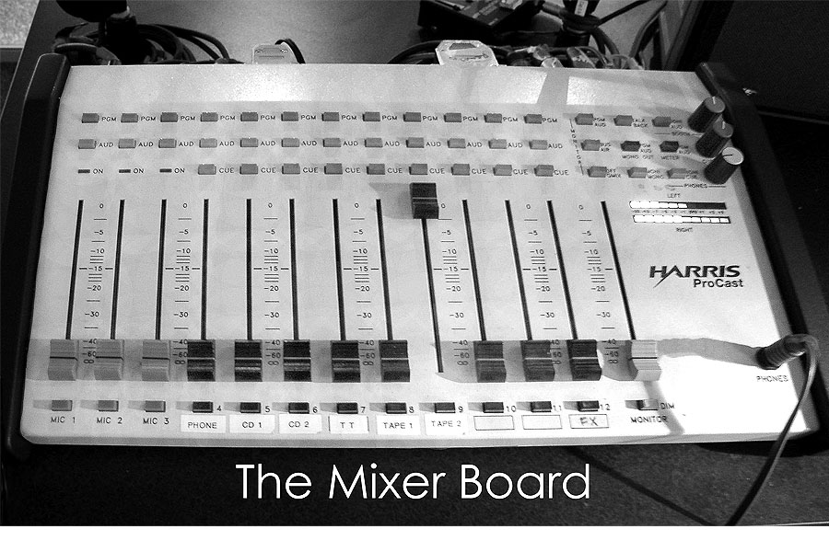
Mixer
3 Mics
Grey, red and blue buttons should be down.
Red controls the stream
Blue controls the headphones
Grey controls the monitor
Mics can only be heard over headphones
Don’t worry about nine buttons on the side
The 3 dials on the left
Grey dial is volume for the speakers
Blue dial does nothing
Red dial is volume for the headphones

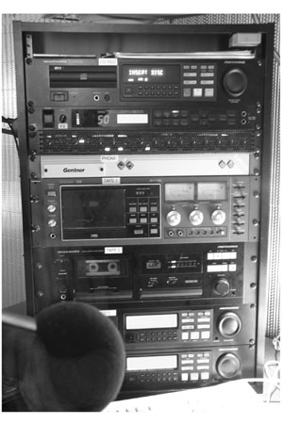
The Rack
Tape Machine 1
Tape Machine 2
CD Recorder
CD Player 1
CD Player 2
The Phone

Audio Sources

Computer
You can use the computer to gain access to many different media sources.
- MegaSeg
  - Automation / DJ assist software
  - MP3 mixing
  - 20,000+ song playlist
  - Local music playlist

The Phone
People can call you live 513-564-9600.
There is one dedicated line to the studio and radio room
Turn the ringer off on the phone!
Pick up receiver and press the on/off button - on button picks it up, off button hangs up. If you don’t press the off button, no one else can call you.
Light will flash when someone is calling (substitutes for the ringer).
Use the pot for phone to get the caller on the air and take them off the air before hanging up so you don’t hear the click
Remember to press off button on Gentner machine to hang up the line will remain engaged and no one else will be able to call in

The Tape Machines
Cue them up to the song you want to play and then with your finger or pen, rotate the cassette back 90 degrees (1/2 a turn)
The pots control the sound again.

The CD Players
The songs count backwards, so you know how much time you have left before it ends
Red light flashes on end button 30 seconds before the end of the song

Record the show
The CD’s are only a dollar up front or you can buy your own. This is a dandy idea in order to get better. You can listen to yourself for timing, plus you can make copies for people who were not able to listen to the show.
Put in a blank cd-r
Push eject button to close
Will say ‘reading’ and ‘initializing’, then 0:00
Press button rec/mode button 3 times to say record manual
Then press the red button to record
Press the stop button to end
After show, press the final button
It will take 2:10 to finalize the disc
If the disc is not finalized, and no one uses the radio room / cd recorder, you can still go in the next day, put in your disc and press final; it will finalize your cd

Preparing for your show
Show up at least 15 minutes before you air.
Pick out your songs and order in advance of the show
If you have a guest, prepare them with some questions you will ask, what the topic of the show is, what subjects you want to cover…
If you have a phone guest, make sure they have the phone # (513-564-9600) and agree on the time they will call.
Write down some questions you will ask, topics you want to cover, and estimate how long you will spend on each topic.
Paper and pen to make notes
Stand up when talking. You will stand in front of the mic and you will sound more active. When standing your voice projects much better as well.

STATEMENT OF COMPLIANCE

The undersigned applicant agrees to accept full responsibility for program content submitted for broadcast. The applicant hereby agrees to indemnity and hold harmless Media Bridges Cincinnati, its affiliates, officers, agents and employees from liability, legal fees and other expenses incurred as a result of broadcasting this message. The applicant recognizes that Media Bridges Cincinnati is to maintain, available for public inspection, a record of all persons applying for use of WVQC airtime and agrees that this application may be used for such records. False or misleading statements made is this application are grounds for forfeitures of the right to use community production equipment and present programming or community messages on WVQC plus other remedies in law or equity which may be available to Media Bridges Cincinnati.

My signature below verifies that I have read this Statement of Compliance and agree to abide by its terms.

Name (please print)__________________________________________________________

Signature of Applicant__________________________________ date __________________

If producer is under the age of 18, a parent or guardian must sign below.

Parent/Guardian Signature_______________________________ date __________________

Brace yourself. The Seven Dirty Words you can’t say on the radio are: fuck, shit, piss, motherfucker, cocksucker, cunt and tit.

